DevOps DAY –6

Final Project

Java Application Deployment in Minikube

deployment.yml

apiVersion: apps/v1 kind: Deployment metadata:

name: my-deploy namespace: my-bank labels:

name: my-deploy spec:

replicas: 1 selector:

matchLabels:

apptype: web-backend strategy:

type: RollingUpdate template:

metadata: labels:

apptype: web-backend spec:

containers:

- name: my-web

image: santhosh/new-imagw:latest

ports:

- containerPort: 9001

apiVersion: v1 kind: Service metadata:

name: my-service namespace: my-bank labels:

app: my-service spec:

type: NodePort

Minikube

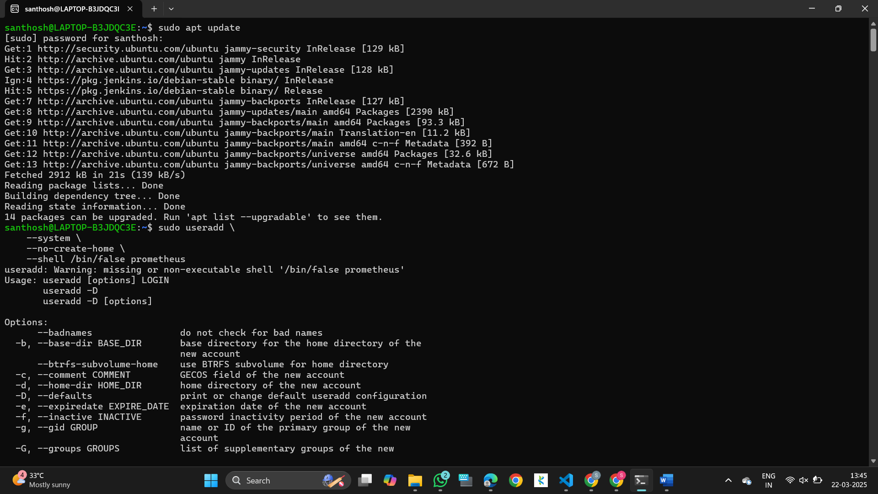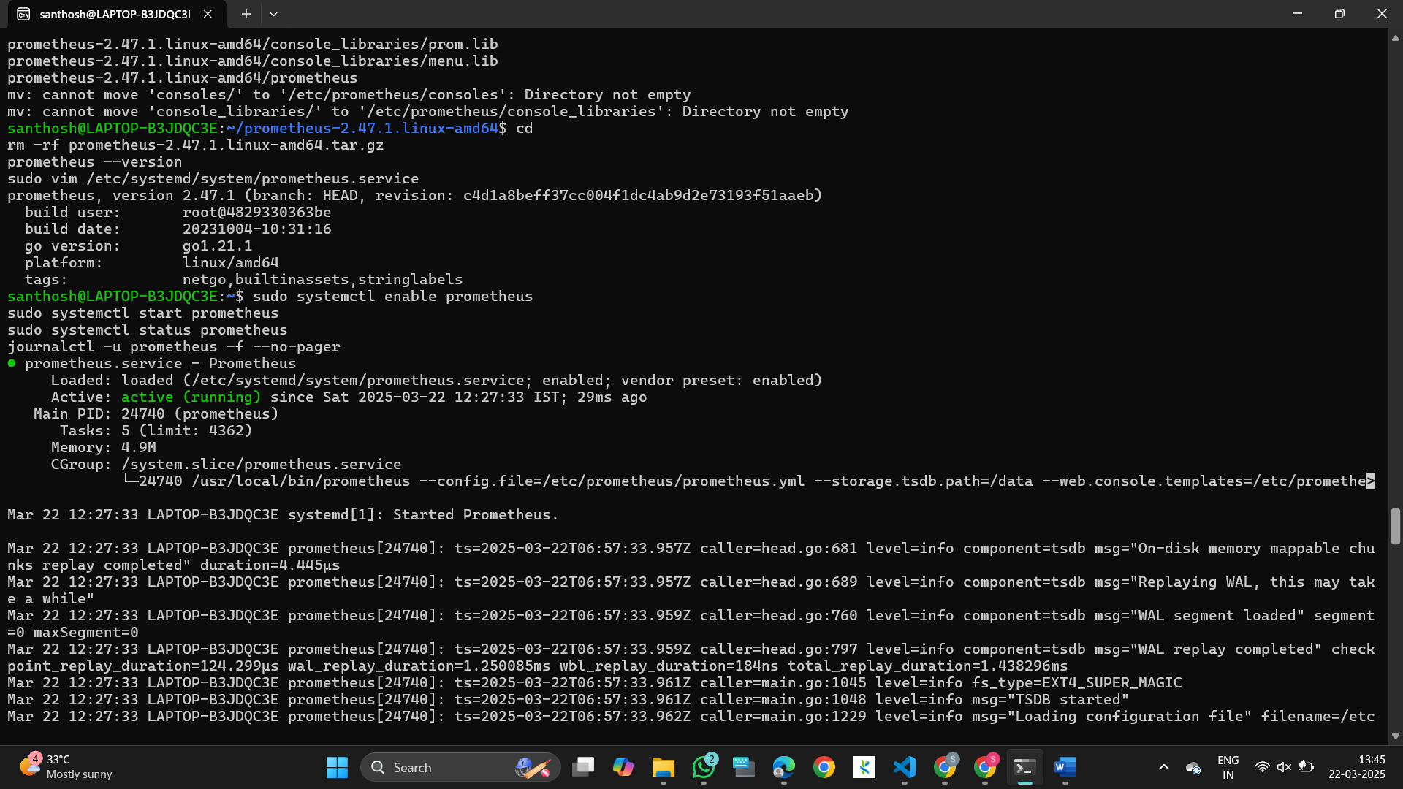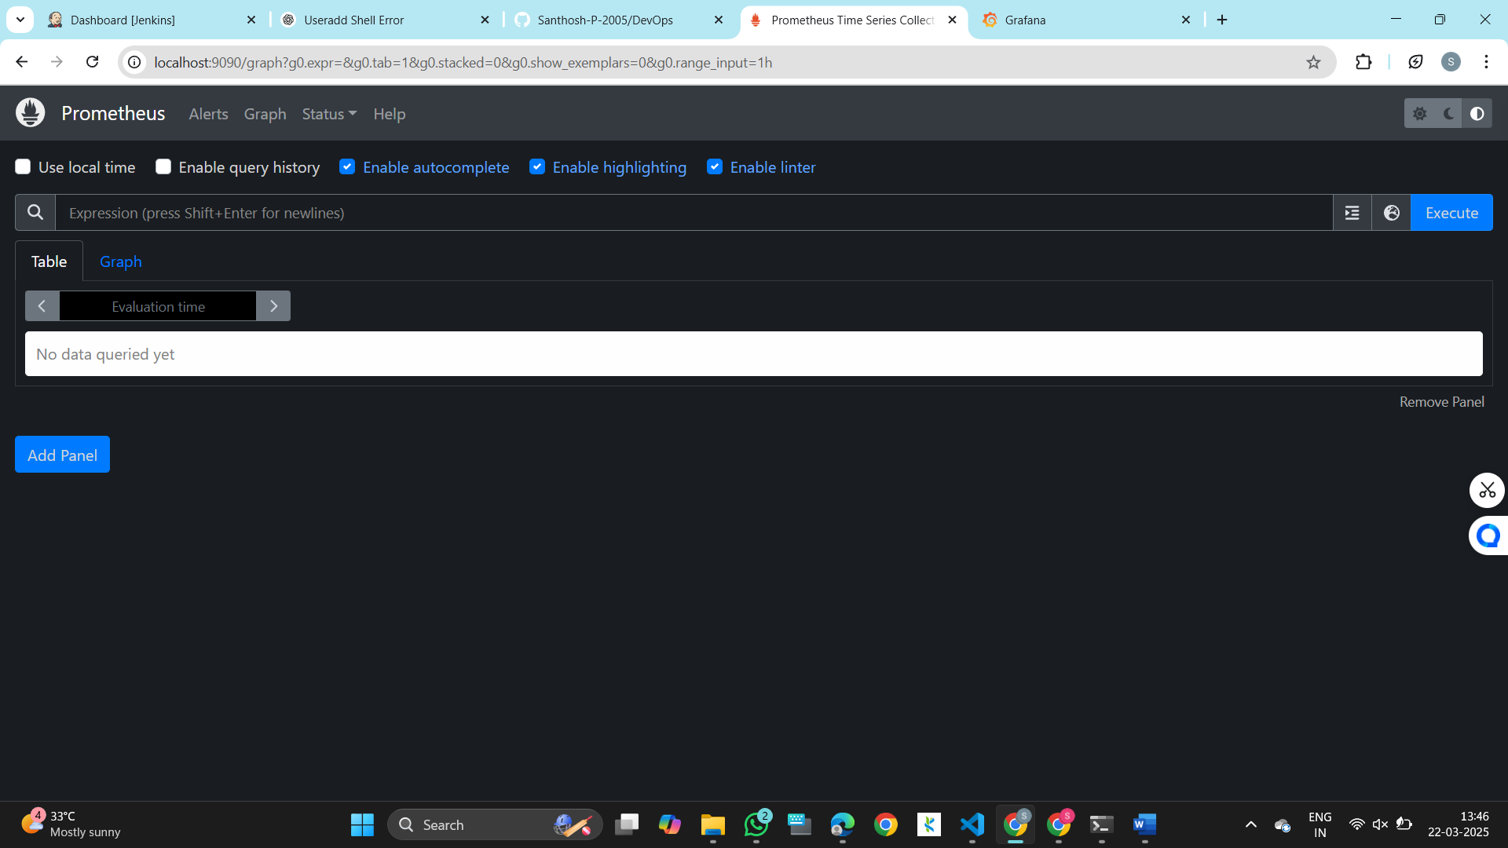

Pipeline script – jenkins JAVA Application pipeline {

agent any

stages { stag ('scm') {

steps {

git branch: ''

}

}

stage('builb-clean') { steps {

sh "mvn clean"

}

}

stage('build-validate') { steps {

sh "mvn validate"

}

}

stage('build-com') { steps {

sh "mvn compile"

}

}

stage('build-test') { steps {

sh "mvn test"

}

}

stage('build-install') { steps {

sh "mvn package"

}

}

stage('build to images') { steps {

script{

sh 'docker build -t .'

}

}

}

stage('push to hub') { steps {

script{

withDockerRegistry(credentialsId: 'Docker_cred', url: ['https://index.docker.io/v1/](https://index.docker.io/v1/)') { sh 'docker push '

}

}

}

}

stage('Deploy App') { steps {

withKubeConfig(caCertificate: '', clusterName: 'minikube', contextName: 'minikube',

credentialsId: 'mukubeconfig_011', namespace: '', restrictKubeConfigAccess: false, serverUrl: ['https://192.168.49.2:8443'](https://192.168.49.2:8443/)) {

sh 'kubectl apply -f deployment.yml --validate=false'

}

}

}

stage('Test') { steps {

withKubeConfig(caCertificate: '', clusterName: 'minikube', contextName: 'minikube', credentialsId: 'mukubeconfig_011', namespace: '', restrictKubeConfigAccess: false, serverUrl: ['https://192.168.49.2:8443'](https://192.168.49.2:8443/)) {

sh 'minikube service my-service --url | xargs curl'

}

}

}

}

